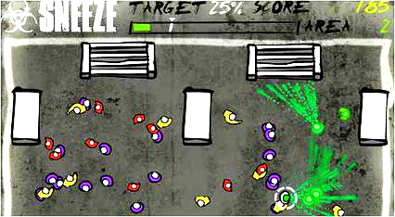

Sneeze Game - The Infection Spreading Game

The Best Team

01/10/2022

Version 1.0

**Table of Contents**

**Executive Summary**

**High Concept**

**Features and Synopsis**

**Play Motivation**

Genre, Platform, and ESRB

Audience and Targeted Customers

Threats and Competition

**Game Differentiators/Unique Selling Points**

**Overall Game Design**

**Game Aesthetic**

**Gameplay Board: Game Core Mechanics**

# Executive Summary

## High Concept

- Infect the most amount of people;

- Sneeze on people;

-Strategize to figure out how to sneeze on the most amount of people

- Gain a high percentage of infected to advance to the next level.

## Features and Synopsis

- The player starts a level by initiating a sneeze on a group of people.

- You can only sneeze once per round.

- Each level has a different environment and different enemies that have unique properties.

- Try to score as high as possible by infecting the most people by the end of the game.

## Play Motivation

- The player must sneeze on another person in order to infect as many people as possible before the infected becomes stagnant.

- Strategy is used to choose the area and person to sneeze on in order to spread the sickness. An infected person only sneezes once and the person then becomes inactive.

- Seeing how the infection spreads should provide the player with a sense of fulfillment, watching the domino effect of healthy people getting infected should lead to a sense of satisfaction/accomplishment to the player.

- Challenge yourself for high scores or the highest percentage of infected people per area. As the player passes each level, the game will become more challenging with different types of infected.

### Genre, Platform, and ESRB

Genre: Strategy based puzzle game,

Platform: PC, Windows

Expected ESRB: E for Everyone

### Audience and Targeted Customers

This game is intended as a casual game that is targeted to players of all ages. This is for gamers who are interested in a fun, casual game that is accessible, intuitive, and easy to play.

### Threats and Competition

* Infection based games(Plague Inc., Infect them all 2: Zombies, Pandemic 2)
* PC puzzle based games

## Game Differentiators/Unique Selling Points

* You play as a virus!
* Many infection-based games are on mobile devices, this game is on pc!
* Strategize the best way to infect people.
* Most infection games you try to avoid the infection, this game you are the infection..
* 10 unique levels with varying difficulty.
* Different types of people that are infected will act in different ways
* Easy to play and understand.

# Overall Game Design

## Game Aesthetic- The game’s graphics are pixelated and use ¾ view for the characters and setting.

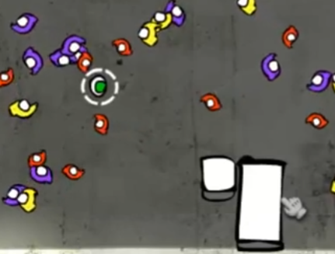

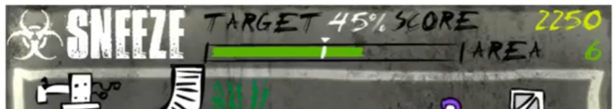

## Gameplay Board: Game Core Mechanics -

## Walk around and set up the perfect sneeze at the start of the round.

* **Limited to one sneeze per round.**
* **Time element for infected and sneezing**
* **Different enemies are easier or harder to infect.**
* **Infected enemies sneeze after a bit.**

